All Agents Must Download first the Citrix Receiver Tool
https://www.citrix.com/downloads/citrix-receiver/
Change Student’s password
Step 1: Access the following URL: https://etools.edukgroup.com
Use these credentials to access
Username: psupport
Password: (Contact our CSM Hyrum Romrell)
Make you copied the password in your clipboard
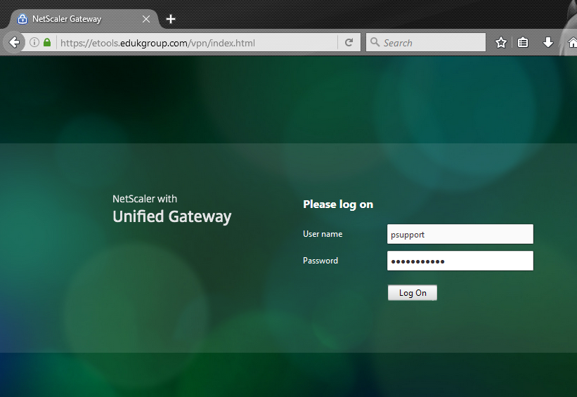

Step 2: Access the Virtual App and Desktop
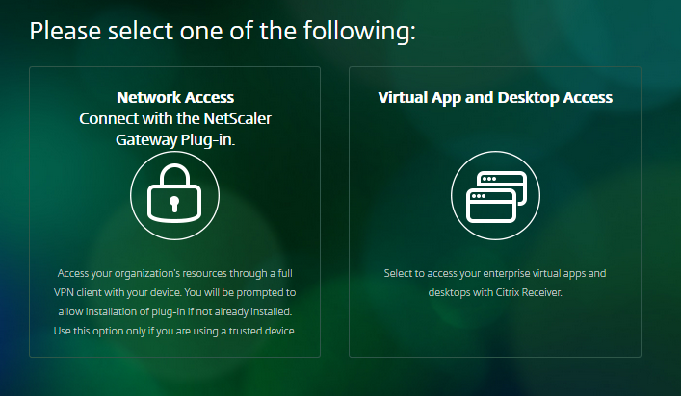

Step 3: Click on the Academic Active Directory icon
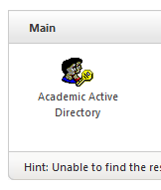

Step 4: Copy the password in Step #1 and Paste it with right click, then Paste and press enter.
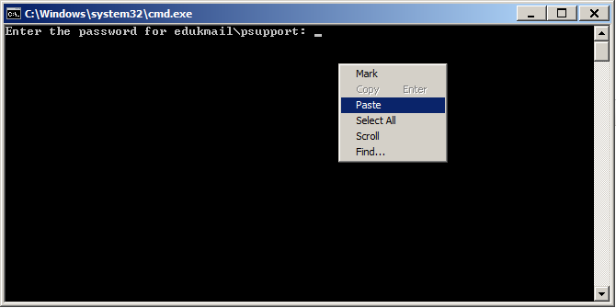
If you ever receive this message after pasting the password in the MS-DOS window, click ok, then close the Active Directory window and try again.
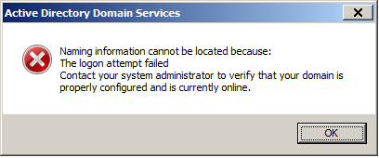

Once you are inside Active Directory, select the domain “edukmail.local” click on the top menu “Action” then “Find…” you can search by:
- Student number,
- Email address, or
- Student's name.
Students show as a number in column Name. Select the object and click from the top menu click File>Properties.

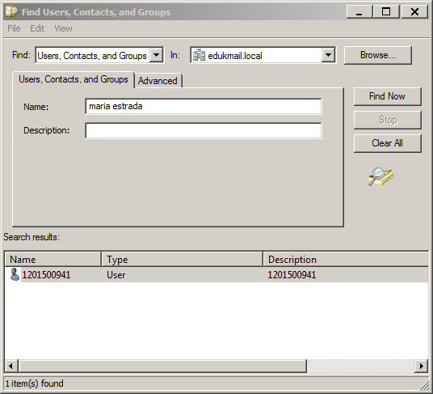
You need to validate the student’s information because more than one person has the same name. Validate the student with telephone number, Student Number, or username. 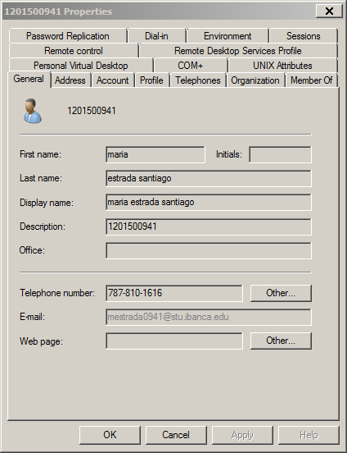

Close this Window and click File>Reset Password… Type the new password twice and check the option “Unlock the user’s account”.
Password Reset Example: First letter from name + firs letter from last name + last 4 digits of student number. (fa4567)

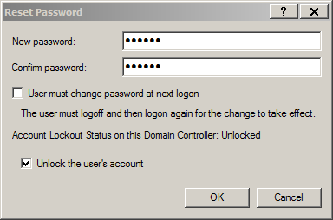
Stay on the phone with the student until the student is able to access Mi Portal , Canvas or Office 365

Access email address – Students
Access the following URL: http://outlook.office365.com
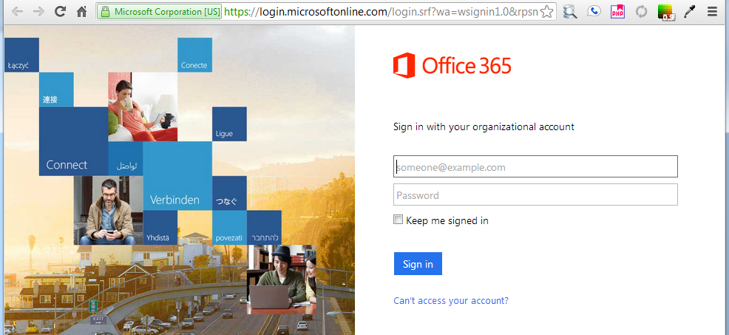

Type the entire email address in the User name text box. Example: farbelaez4567@stu.nuc.edu
